

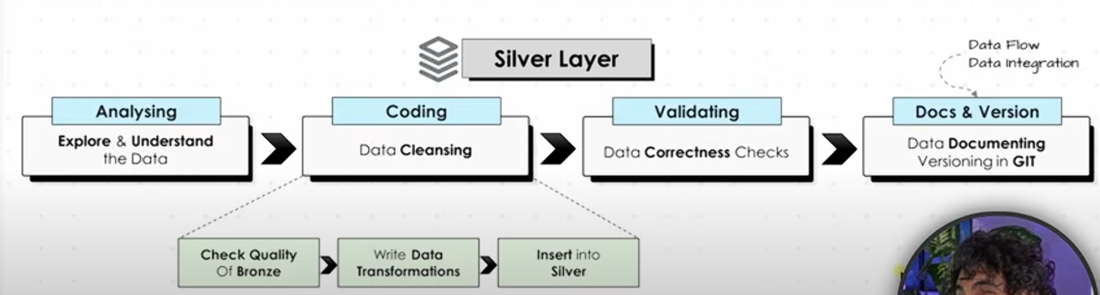



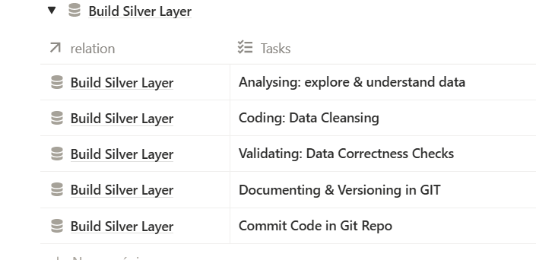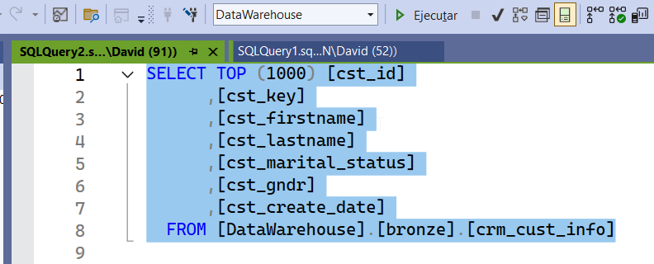



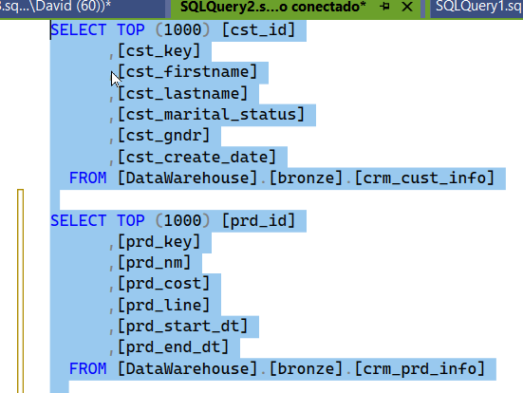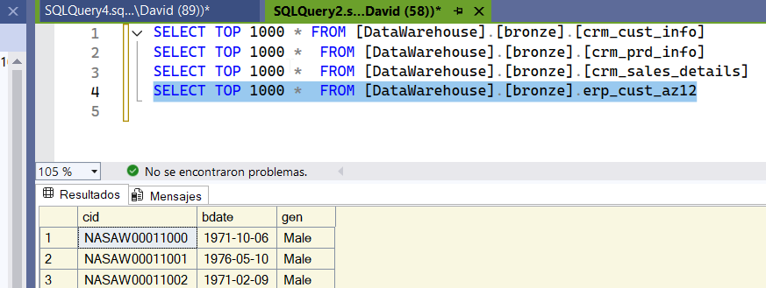

We continue analyzing table by table and put them all in the same query.  
 We look at each table individually and see how we can join them.

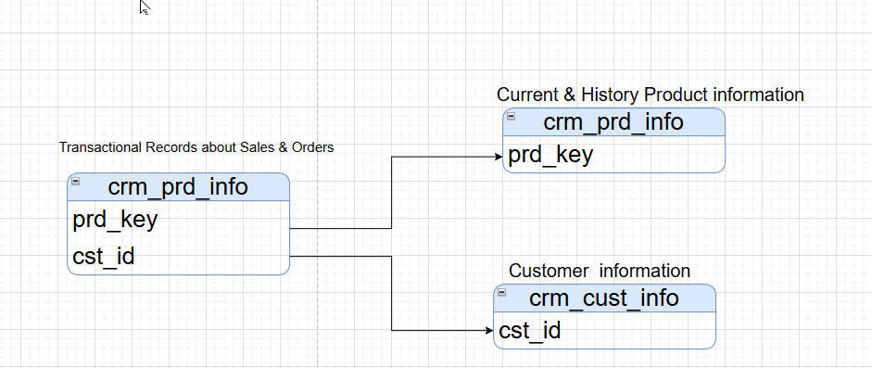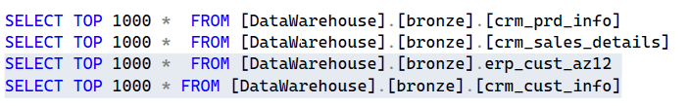

Little by little, we are joining the tables.

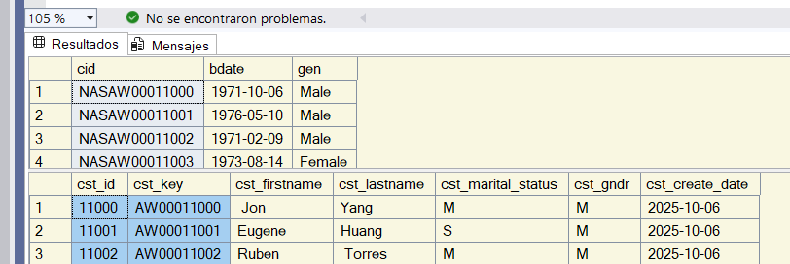

We can join these two tables using the customer_key ID.  
 CTRL+Enter adds a new row in Vaio.  
 ERP PX catalog contains product categories and subcategories. We have special identifiers for that information.

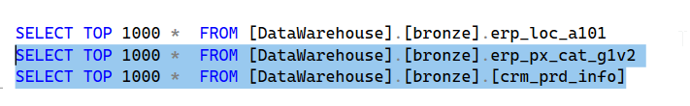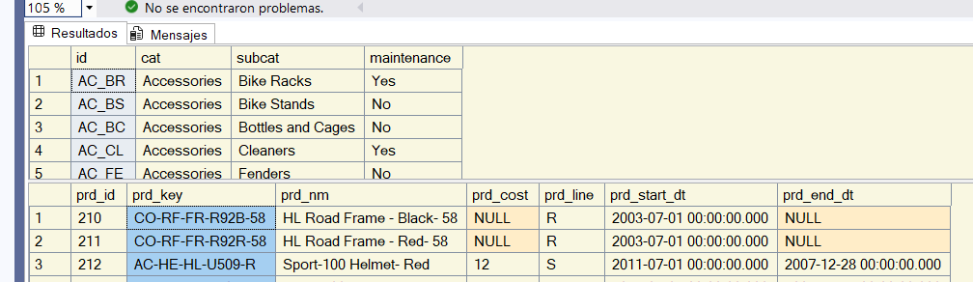

We can join those two tables using the source system CRM.

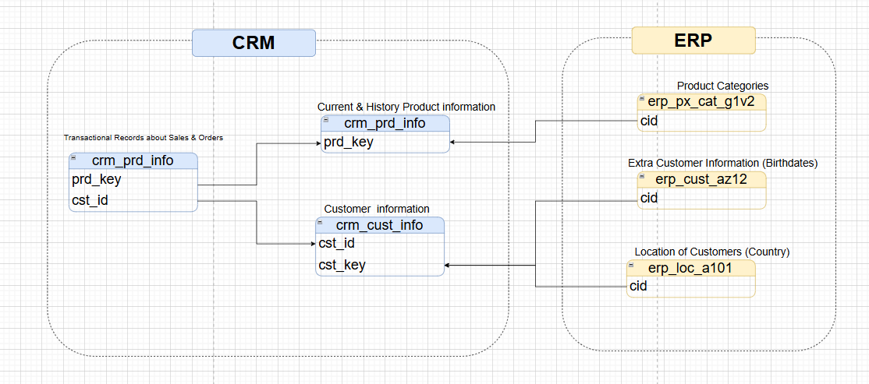

Now it’s much clearer how the tables are connected to each other.

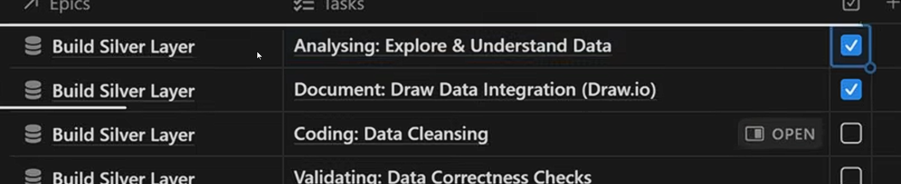

DATA JANITOR

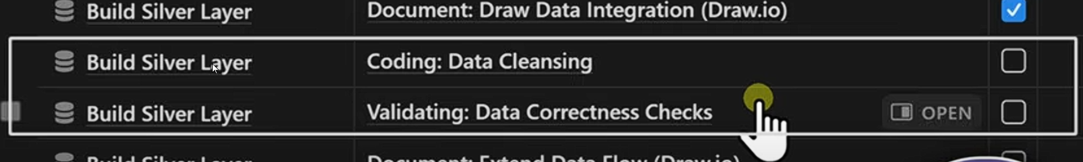



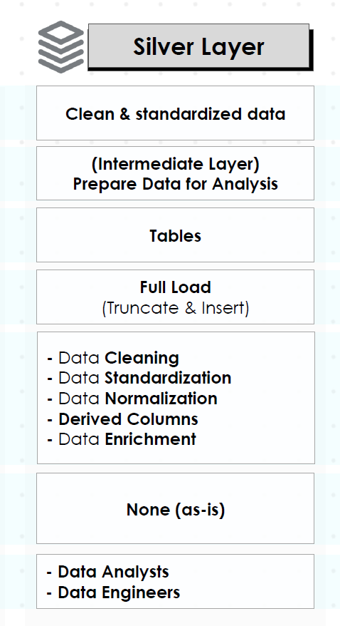

In this part, we have a lot of data transformation.These are extra columns or fills that the data engineers add to each table and don’t come directly from the source system.

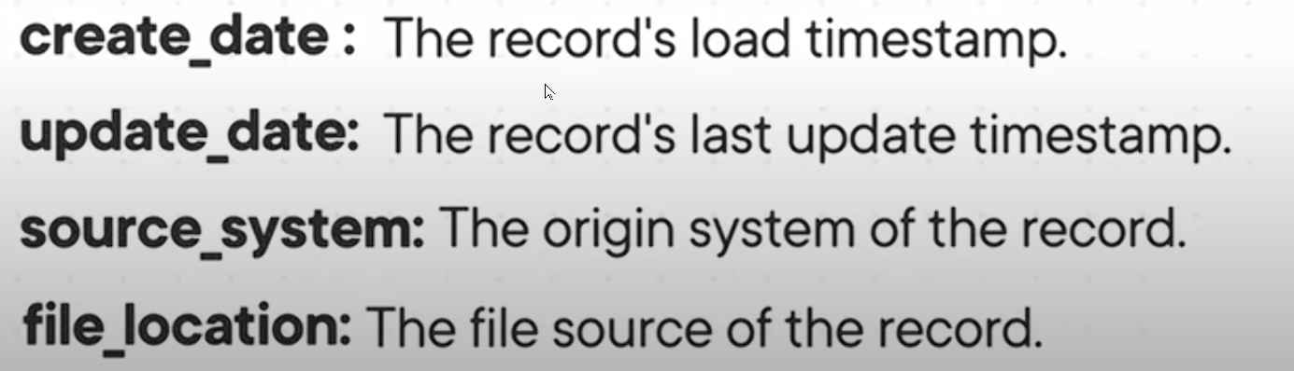

its good to see if I have gap in my data. Specially if I have increments. Its like put leaves on everything.

We will add a default value for the date. I want the database to generate this information automatically.

the naming convention is very important. and then we repeat the same thing for all other tables.

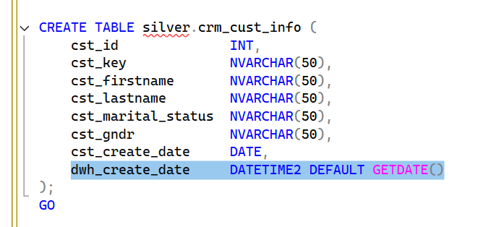 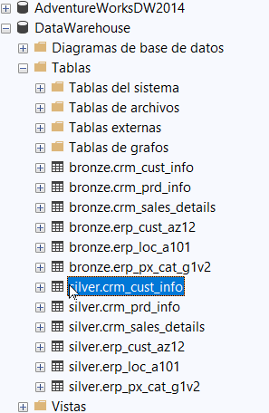

The commands have completed successfully. End time: 2025-10-13T12:46:42.4945016-03:00. There we created 6 tables.



Before writing any query, we need to assess the quality of the Bronze layer. First, we look at the quality issues, and then we start writing our code.  
 We’ll review all the tables in the Bronze layer, clean them, and then insert them into the Silver layer.

-- Check for nulls or duplicates in Primary Key

-- Expectation: no result



To detect duplicates in the PK, we aggregate the primary key. If we find any value that appears more than once, it means it’s not unique and we have duplicates in the primary table.  
 We’re interested in the values that are greater than 1.

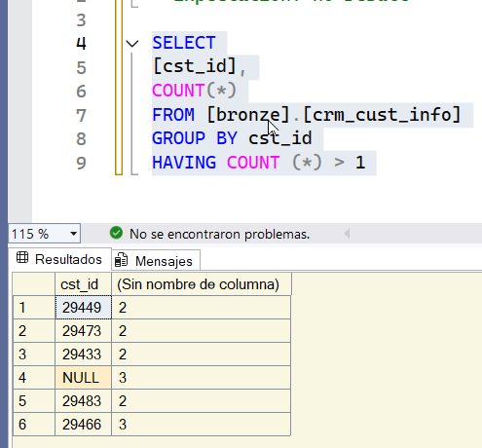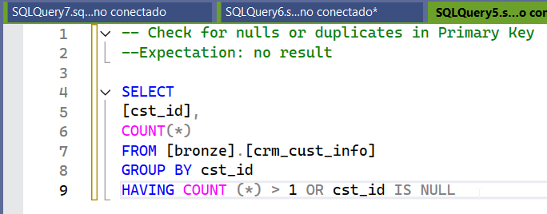

We have the following issues in this table because this indicates that we have duplicates. Those IDs appear more than once in the table.  
 We’ll start by writing the query that will perform the data transformation and data cleaning.

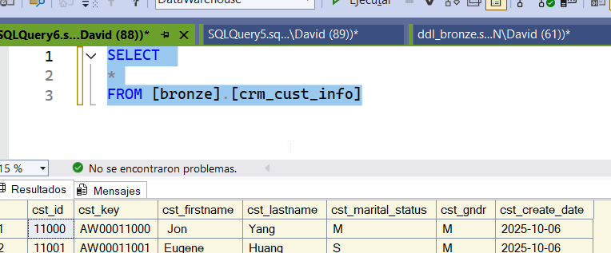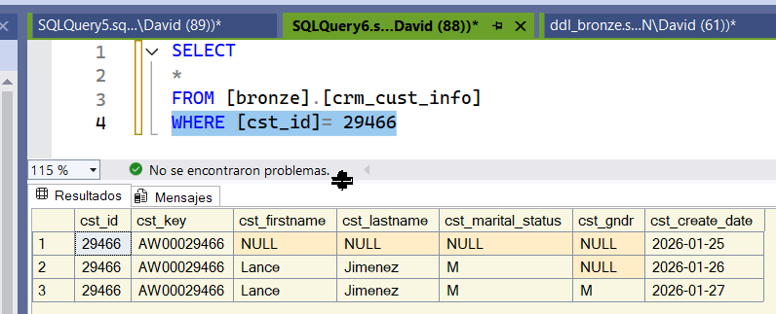

I focus on the issues. The ID is repeated 3 times.  
 Which one do we choose? It’s better to choose the newest one because it has the most up-to-date information.

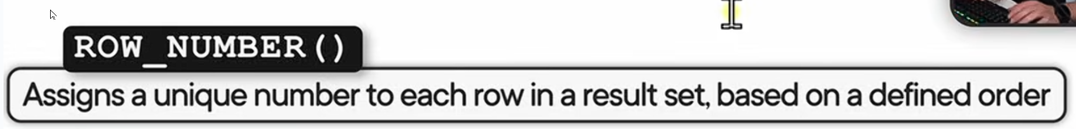

dividimos por customer id

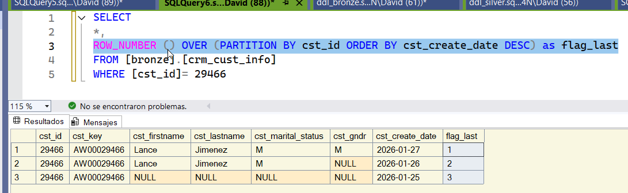

The data is sorted by the creation date.

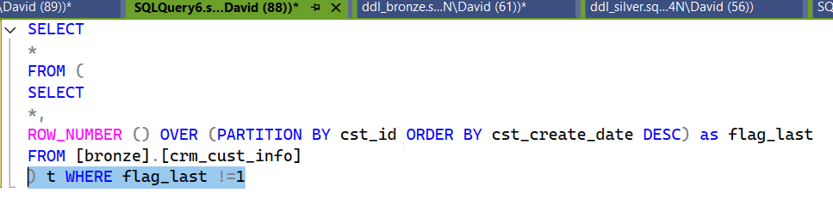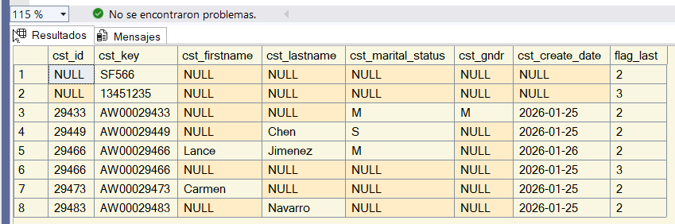

Here we have all the data that we don’t need.

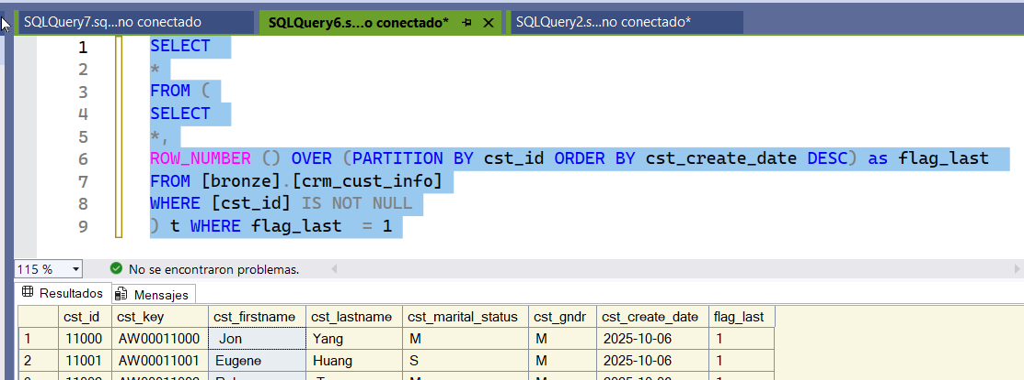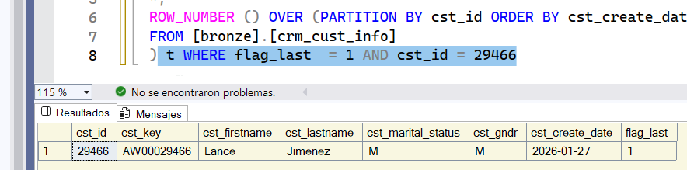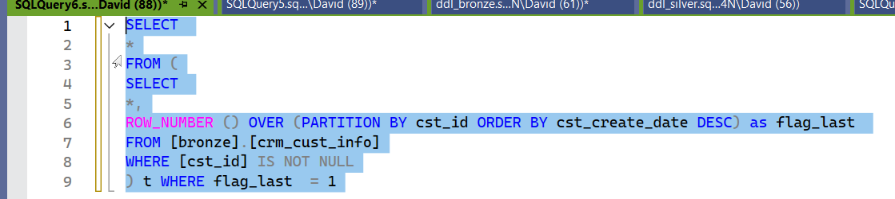

If we do it this way, we ensure that our PK doesn’t repeat and that each value appears only once. This query removes any duplicates.

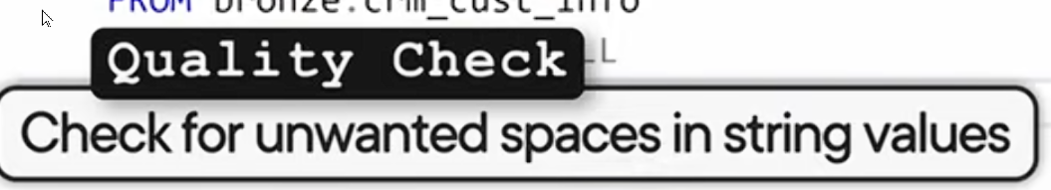

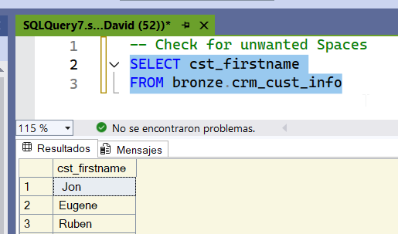

Let’s check for empty spaces. We apply a filter.



The TRIM function removes all empty spaces.

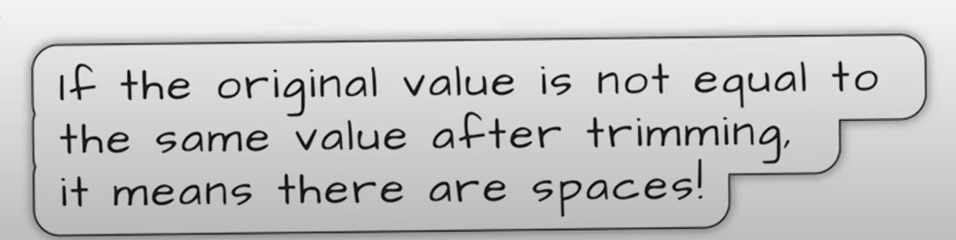

If the first value is not equal to the second value after applying TRIM, then we have a problem.  
 The first name is not equal to the first name after trimming the values.  
 We can also check the last name.

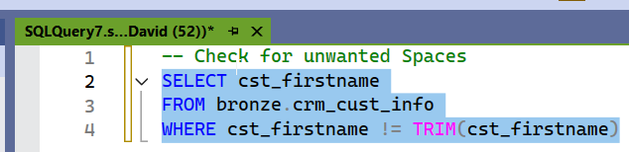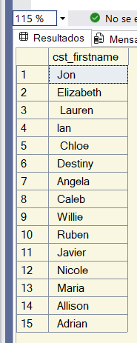

This is the list of all names where we have extra spaces.  
 We perform the same check for the last names. We can check all string values in the table.

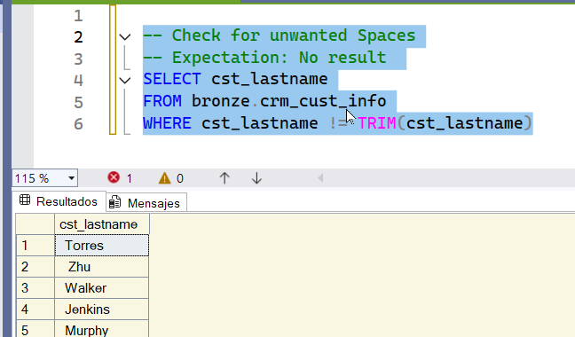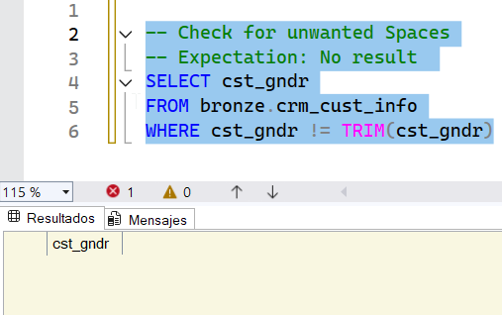

We didn’t get any results, which means the quality is better.  
 Now we’re going to perform a transformation to clean these two columns.

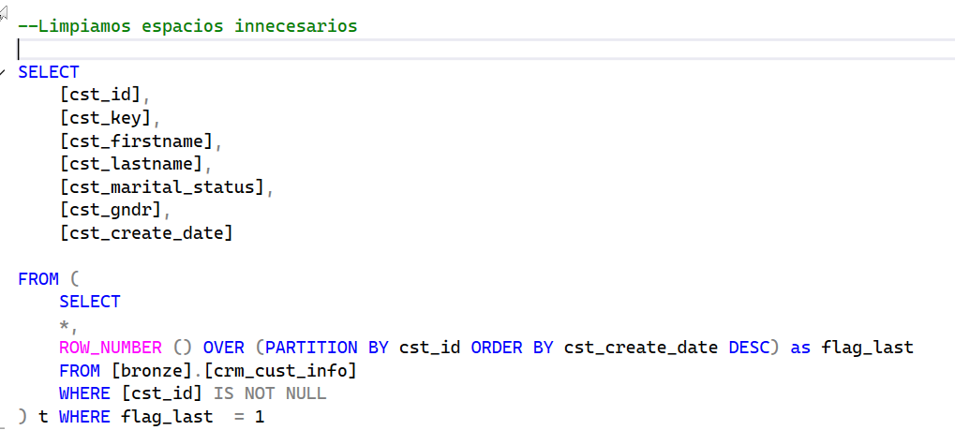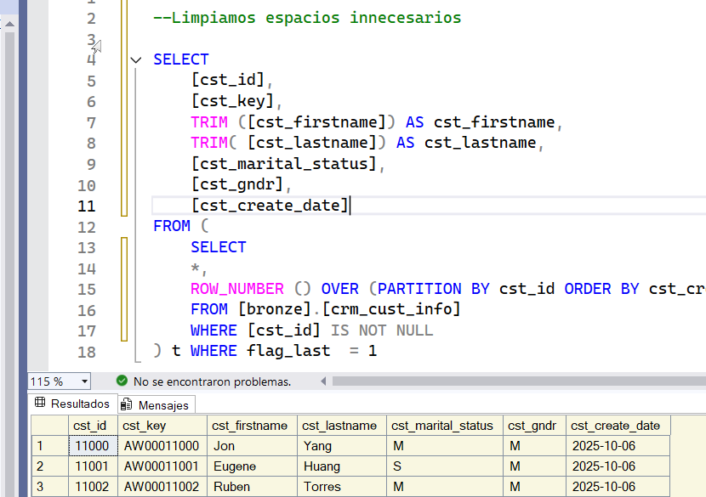

With this, we’ve already cleaned unnecessary spaces.



Now we check the quality of the marital_status and gndr columns.

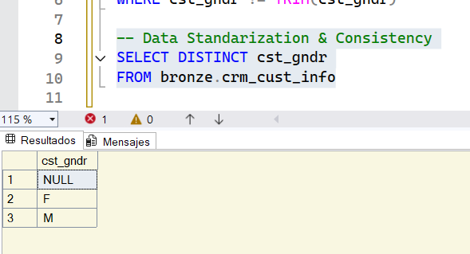

We’re going to change the values F and M to Female and Male.  
 We also need to check for NULLs.

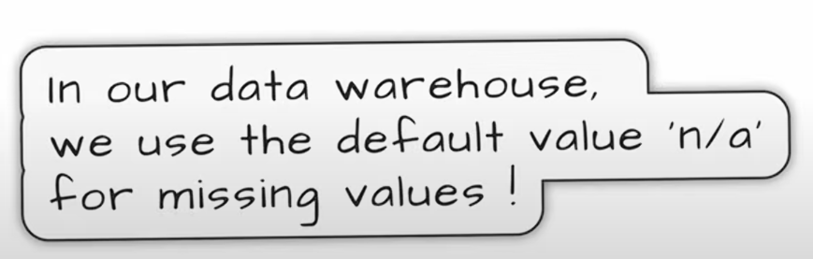

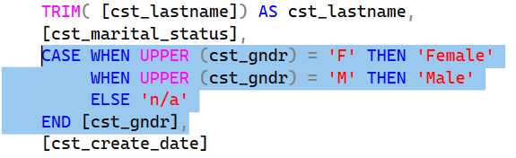

We’ll convert them to UPPER just in case. We use the UPPER function to handle any values that might appear in lowercase.

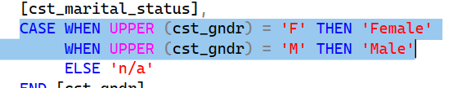

Something else you can add—if you don’t trust the data and want to avoid extra spaces—is to include the TRIM function.

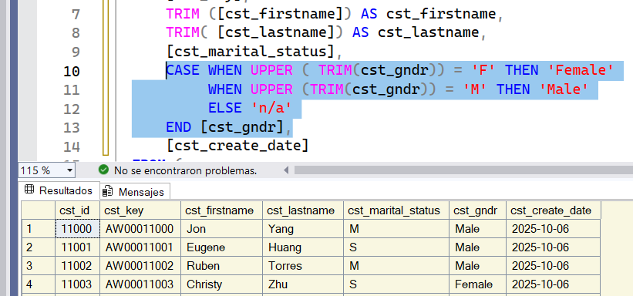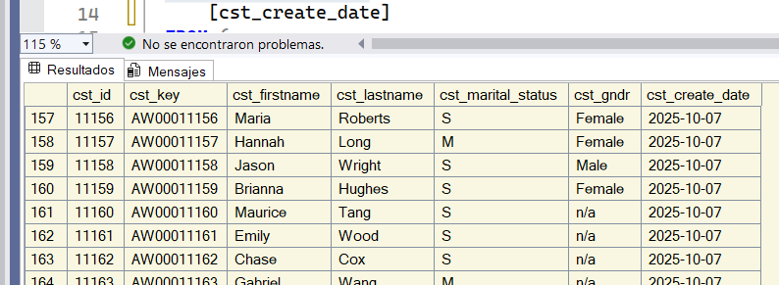

If we don’t get any value, it will show N/A.  
 Now we’ll do the same for marital_status.

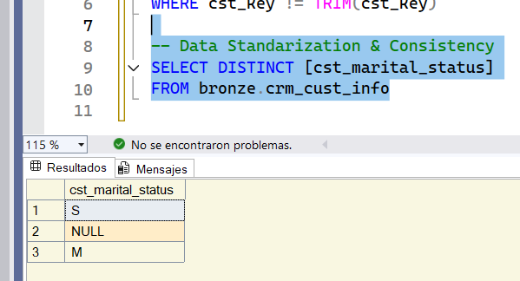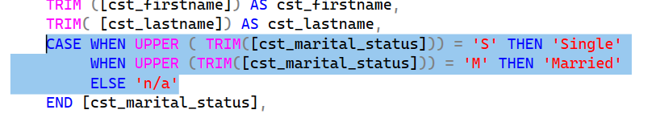

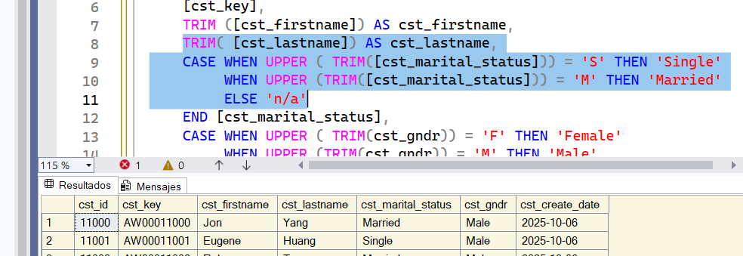

Now, instead of showing S or M, it shows Single or Married.  
 Next, we’ll work on the create_date.  
 Now we’re going to write the INSERT statement.

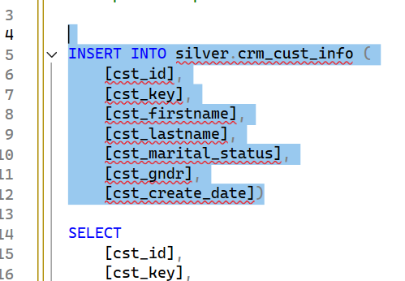

(18,484 rows affected) End time: 2025-10-13T22:09:31.0686826-03:00  
 With this, we have inserted the clean data into the Silver table.

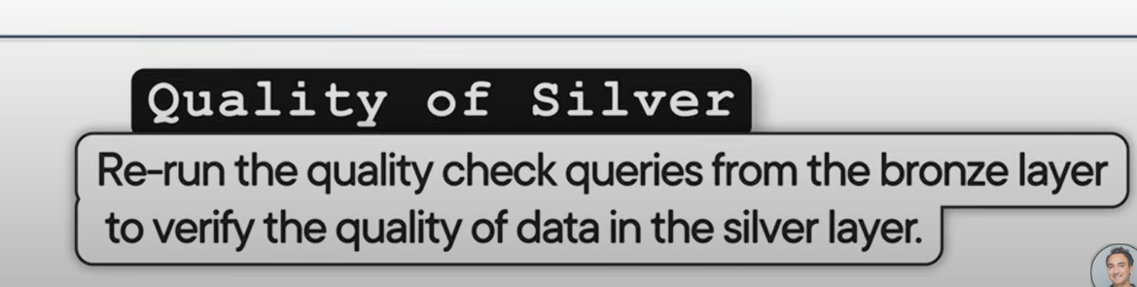

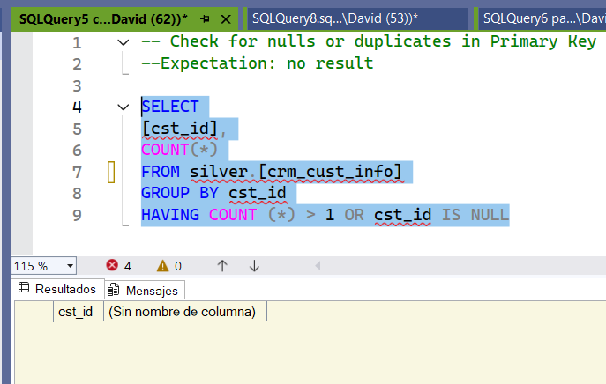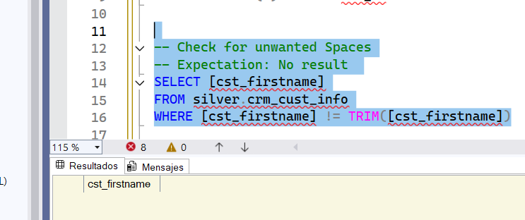

We don’t have any duplicates in the PK.

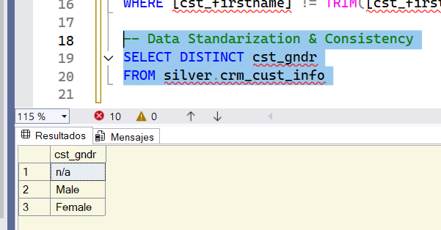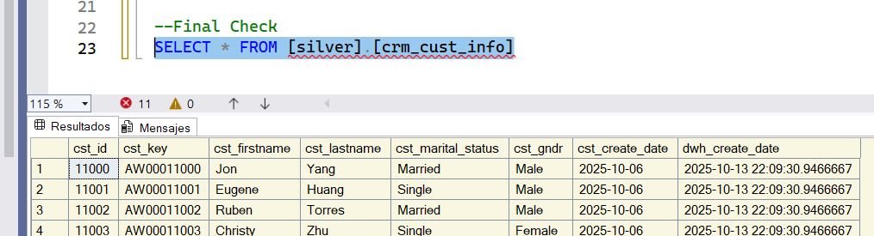

Everything if fine.



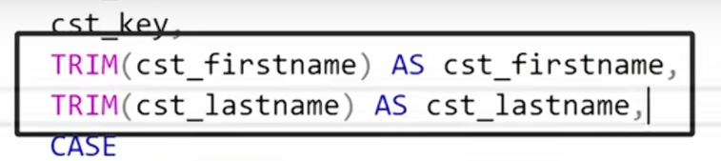



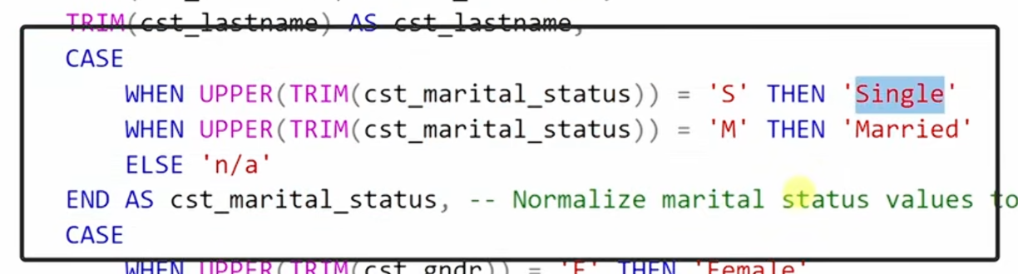



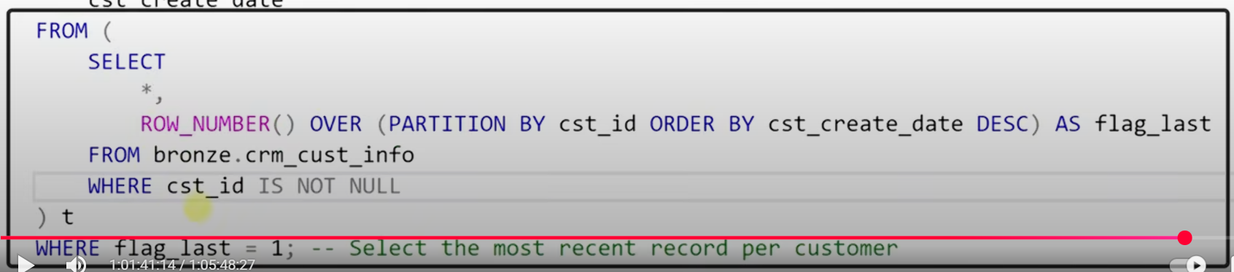

remove the duplicates





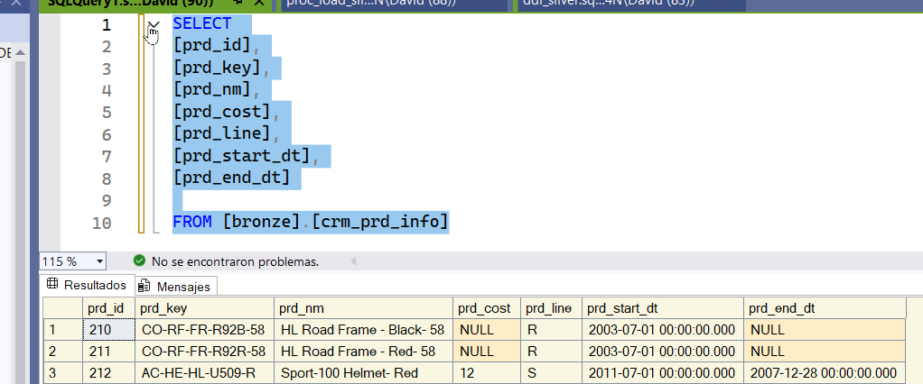

We start with the second table. The first thing we need to check is the PK

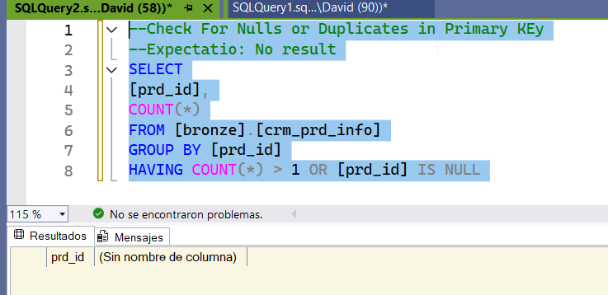

Perfect, the PK doesn’t repeat.  
 Now we continue with the prd_key; we need to split the string into two pieces of information.

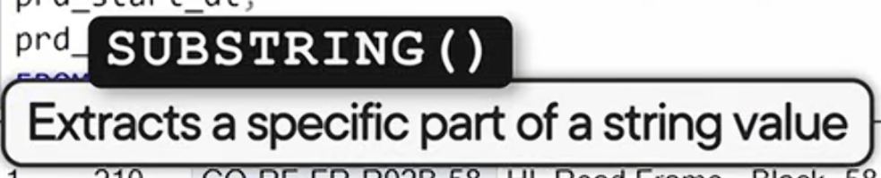

We use the SUBSTRING function to extract part of the string.  
 First, we specify the column from which we want to extract information. Then we define the starting position. Finally, we specify the length.

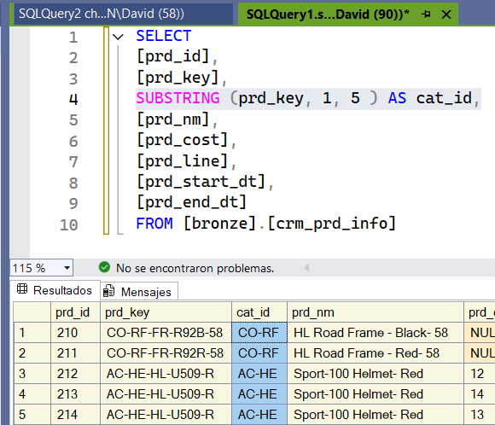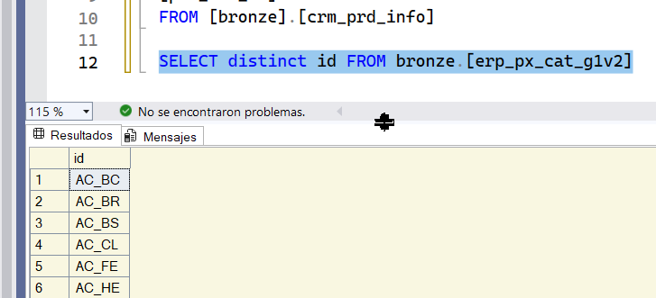

We have a new column called cat_id that contains the first part of the string.  
 Let’s do a double check to see if we can join the data. We’ll check if we can join both tables.



We have a problem: one uses an underscore and the other a hyphen.  
 We’re going to use the REPLACE function.

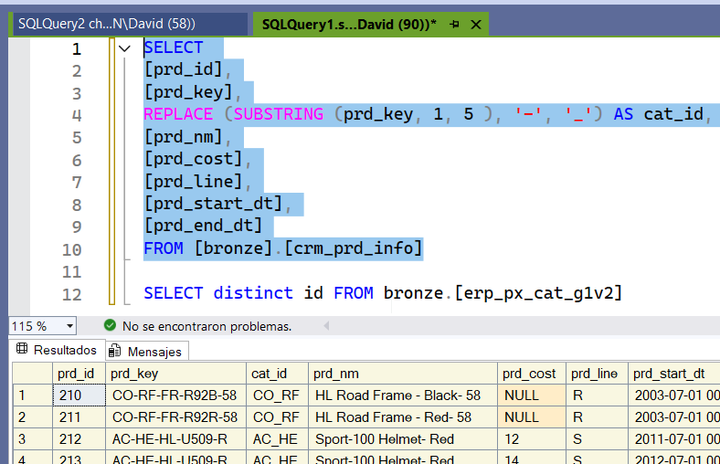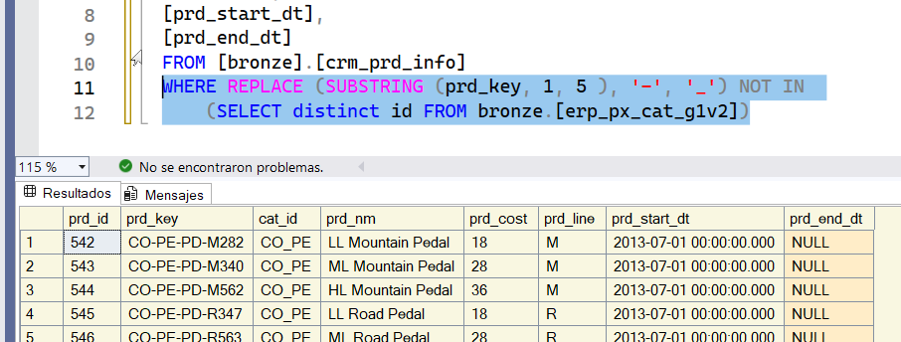

Perfect, we replaced the hyphen with an underscore.

Now we want to check that there isn’t a matching value in the second table.We only found one category that isn’t in the second table. Our check is fine.  
 We already have the first part; now we’ll do the same for the second part.  
 This time, we don’t start at position 1 but at position 7. To make it dynamic and capture the full length, we use the LEN function to get all the characters each item has without losing information.

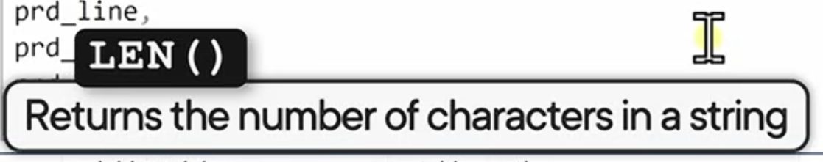

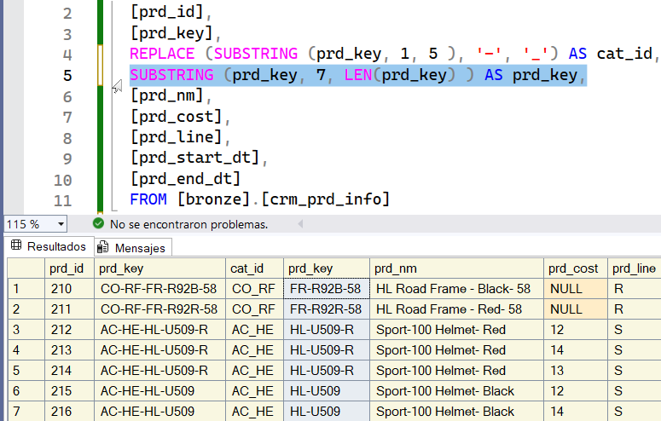

Now we extract the second part from the prd_key string.  
 We do this to join it with the sales_details table.

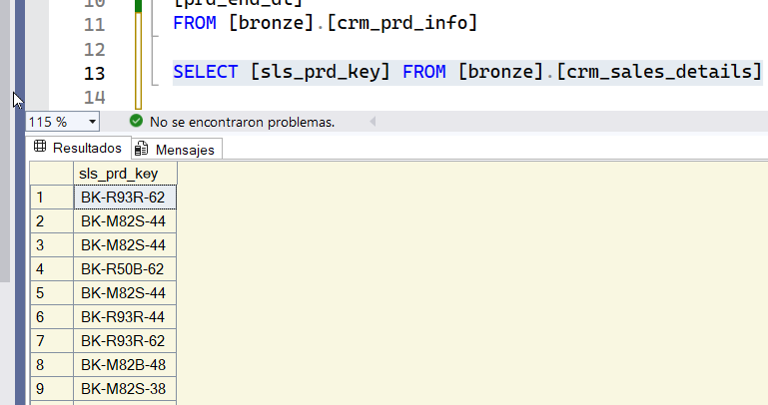 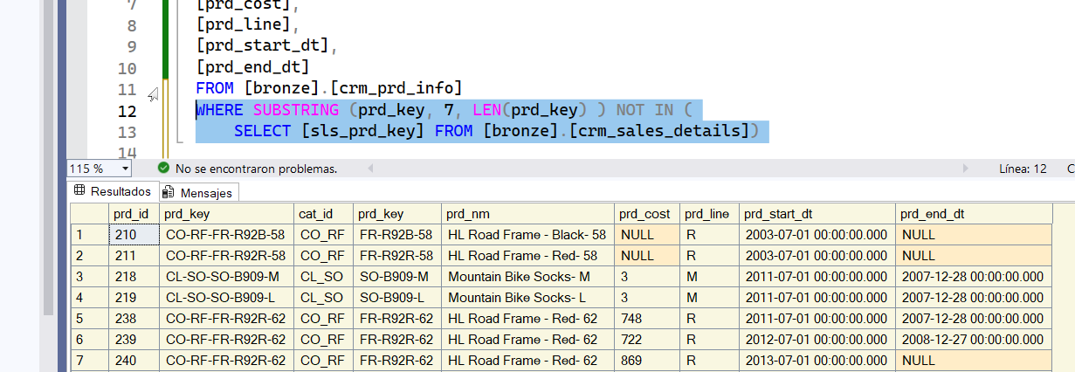

We check the data in the table we want to join.  
 We have many products that don’t have any orders. We don’t have any orders for the product that starts with FK.

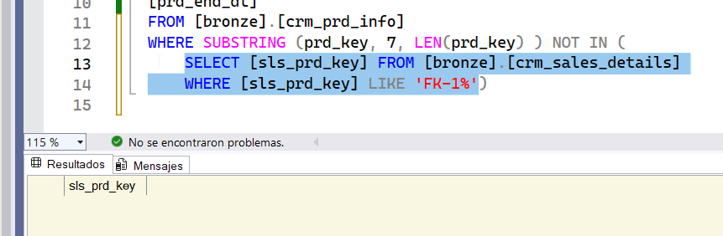

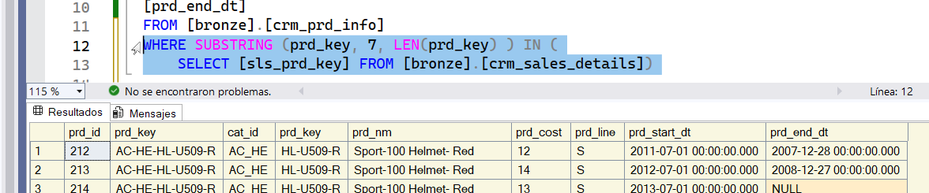

We need to remove the products that don’t have any orders. Everything is fine. There are only products without orders, so we’re good. Next, we move on to product_name, which has unwanted spaces.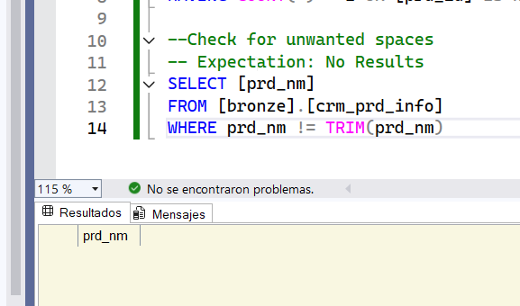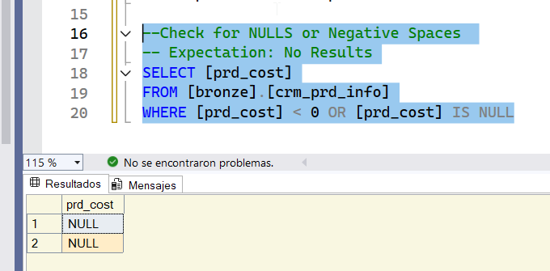

We’ll check that there are no NULLs or negative numbers. There are no negative values, but we do have NULLs.  
 We can replace the NULLs with zeros. ISNULL is used to replace NULL values with zeros.

}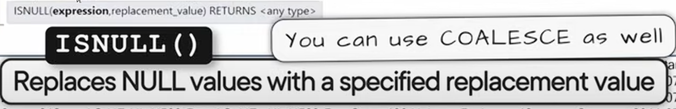

If it’s NULL, then replace that value with zero.

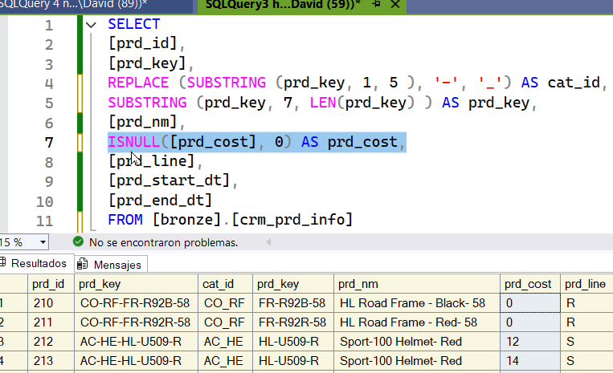We no longer have NULLs; we have zeros. This will help us in the future when performing aggregates like AVG.

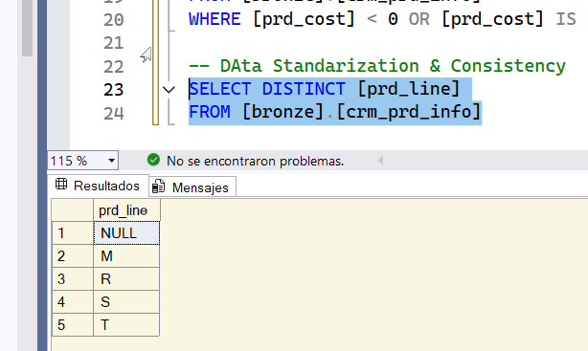 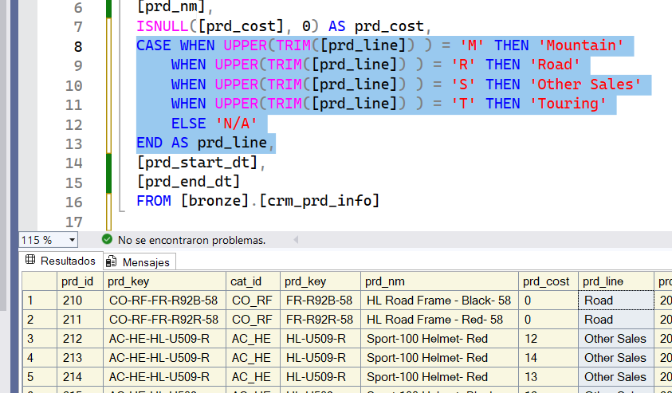

We continue with the next column, prd_line, and review all the options.  
 We transform all the values into more user-friendly labels.

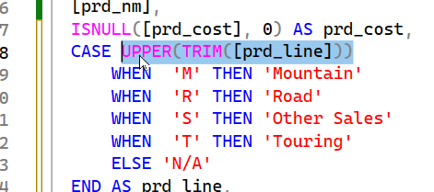

We can write it this way to avoid repeating the same code all the time.  
 Next, we move on to the last two columns.

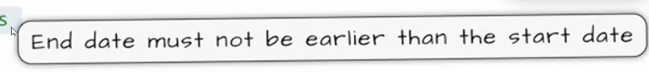

We have a problem because some end dates occur before the start dates.

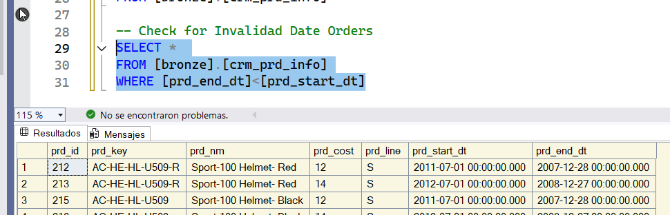

It should have returned a NULL value. We have problems.



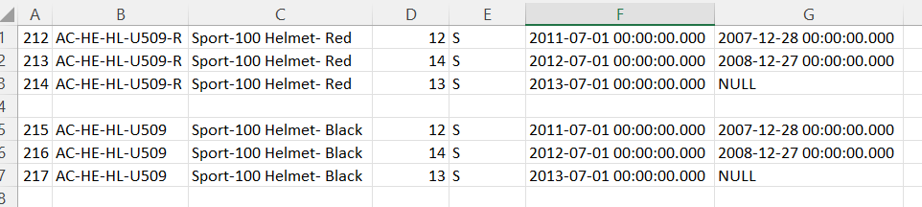

We take these values and do a brainstorming session.

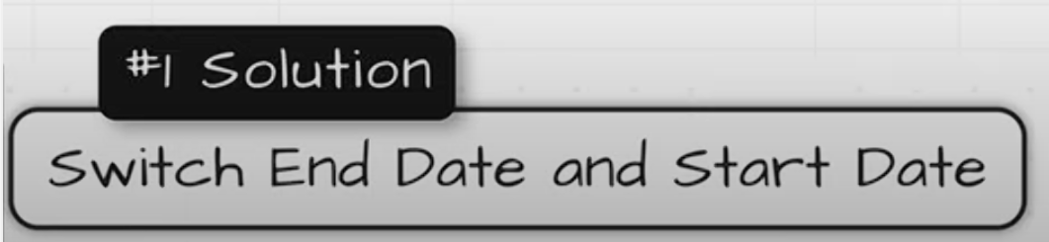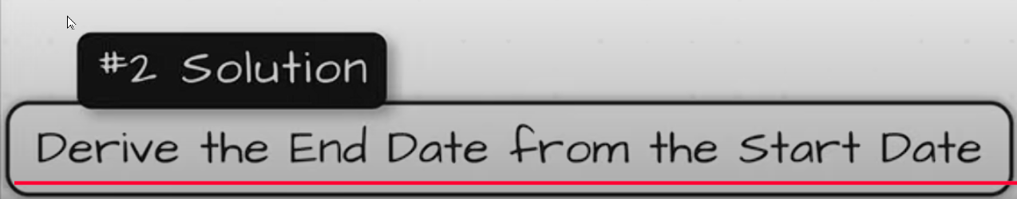

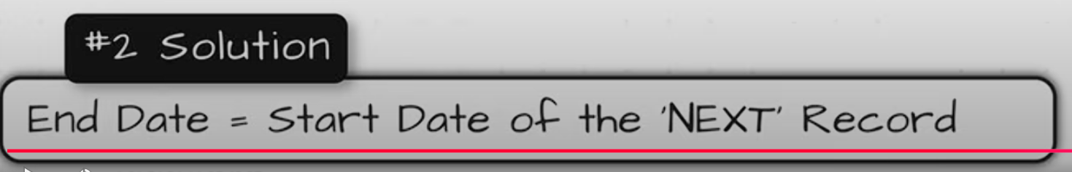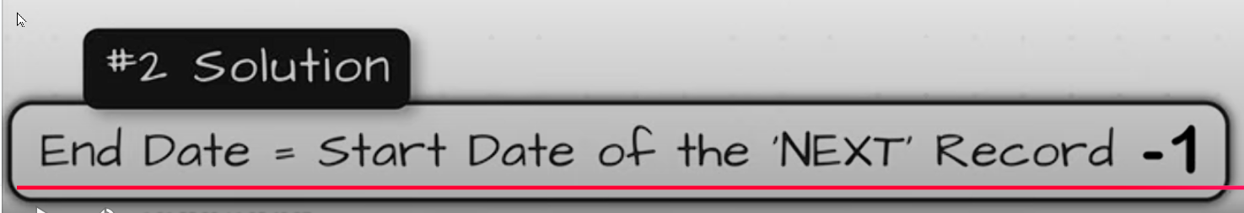



We set the end date equal to the start date of the other order. Then we subtract one day to avoid overlap.

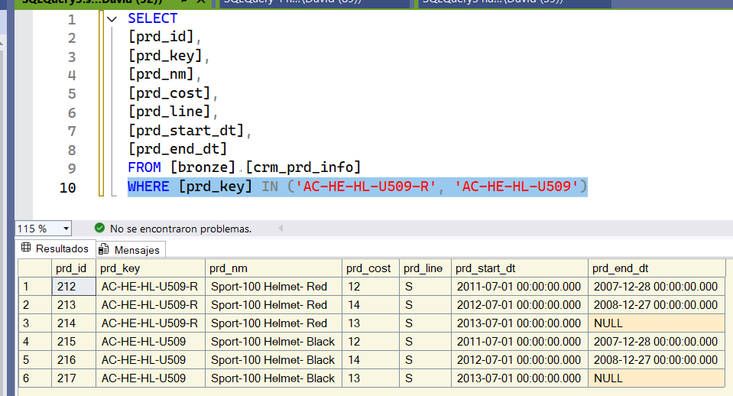

We’re going to work with those two values. Now we build our logic.

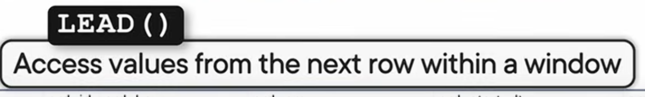

We’re going to use the LEAD and LAG functions.  
 We’ll apply the window function per product. We partition the data by prd_key and then need to order the data.

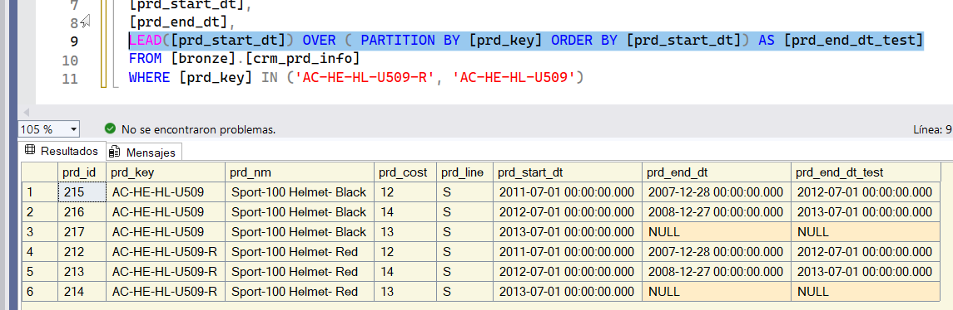

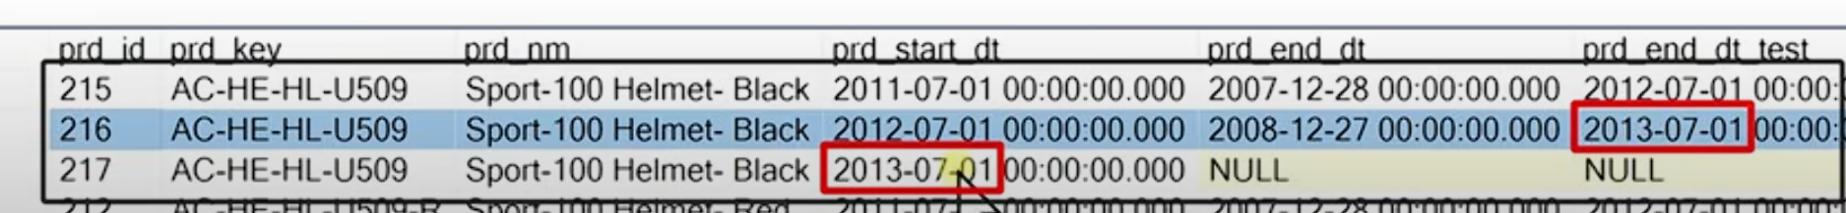

It’s more organized now.  
 We made the end date come from the start date of the next item.

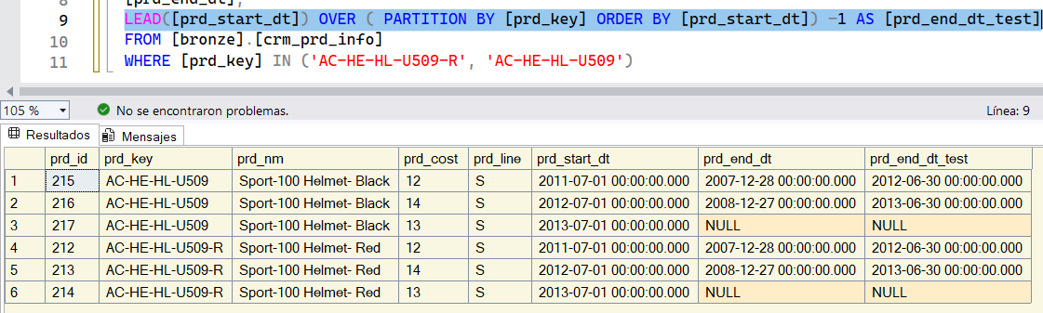

Then we subtract 1, and now it works.  
 Now we replace what we wrote in our main query.

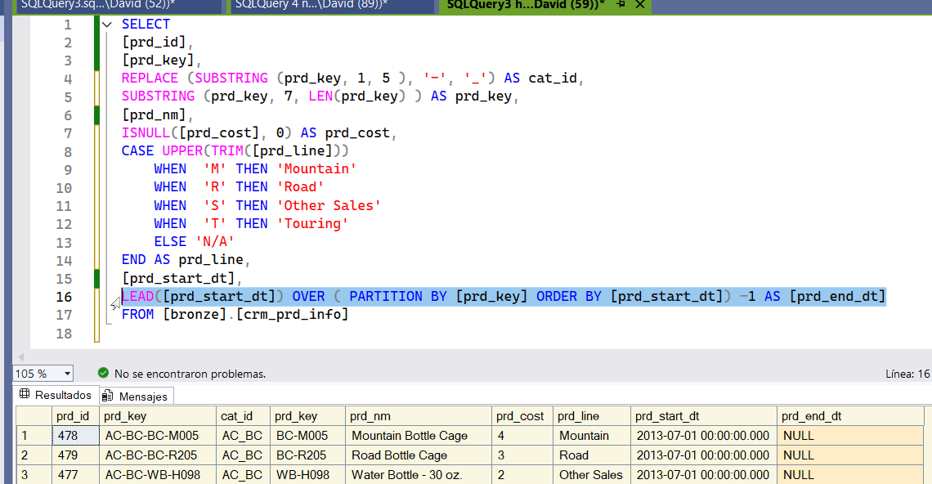

We don’t like the zeros in the start_date.

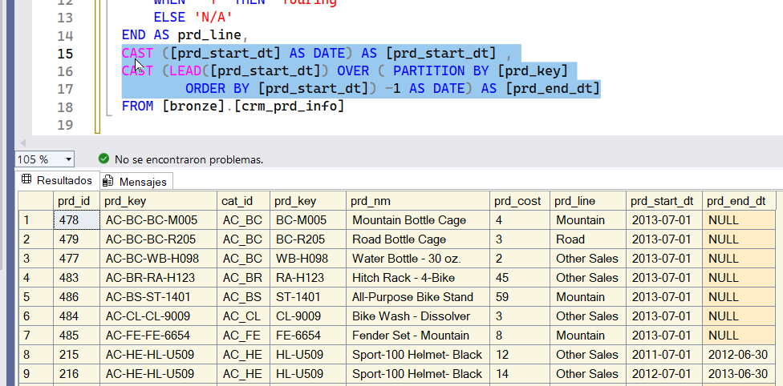

Now it looks much better. We now have clean product information.

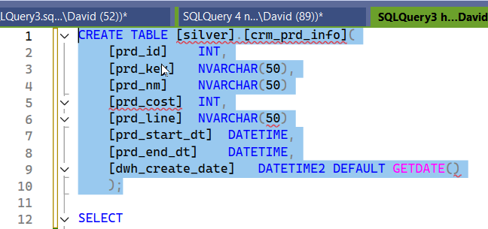

Everything is fine now, but before creating the tables, we need to do one more step.

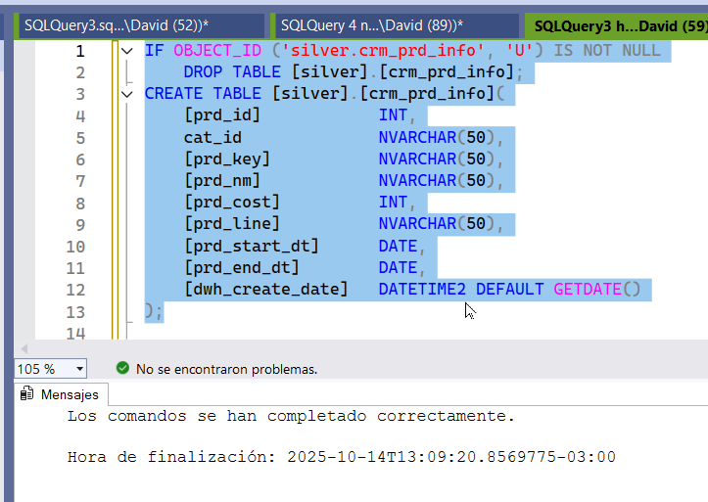

We create our table with the correct formats. Sometimes we need to adjust the metadata if the quality isn’t good. It’s similar to the Bronze layer but with some modifications.  
 Now we insert the clean data into the Silver table.

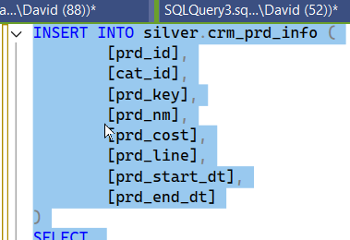

We inserted the data into the Silver layer. (397 rows affected) End time: 2025-10-14T13:19:23.8391306-03:00

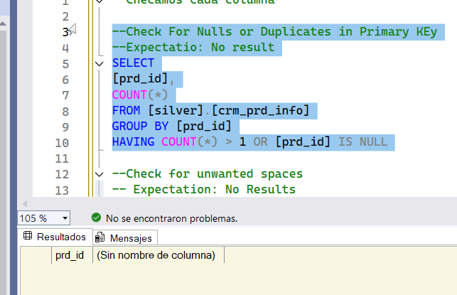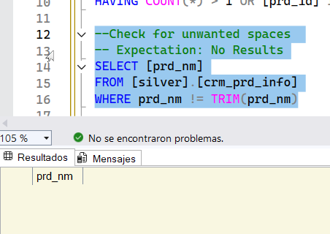

1. We check the PK.

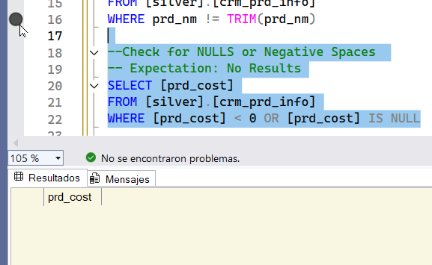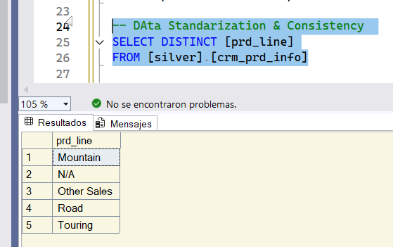

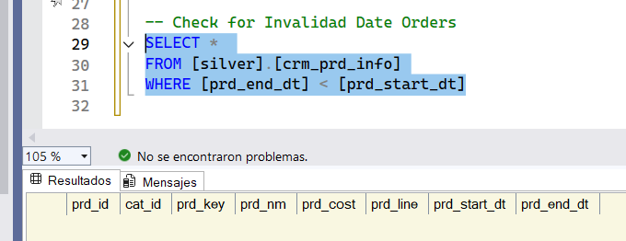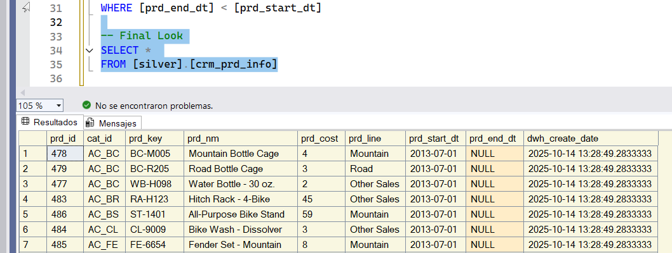The last column is automatically generated by the DDL, indicating when we loaded this table.

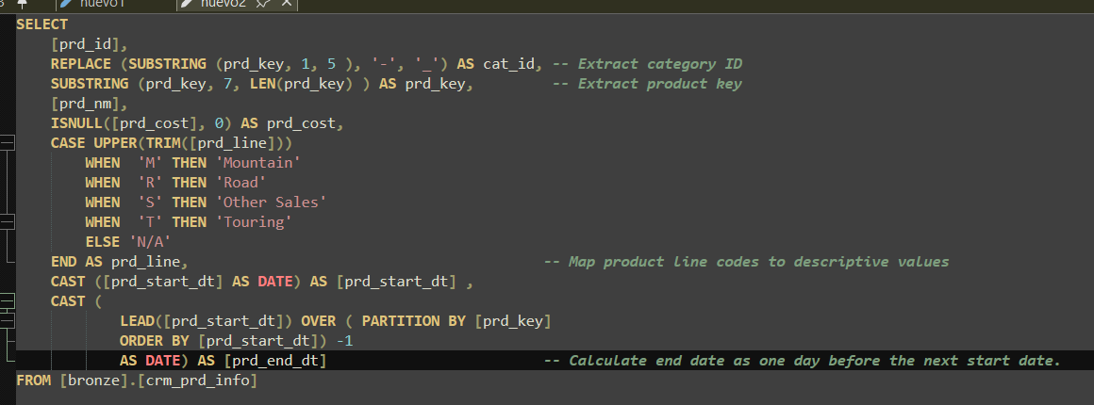We performed the following transformations.



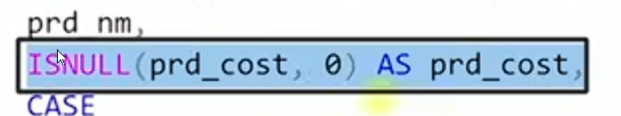We handled missing information.

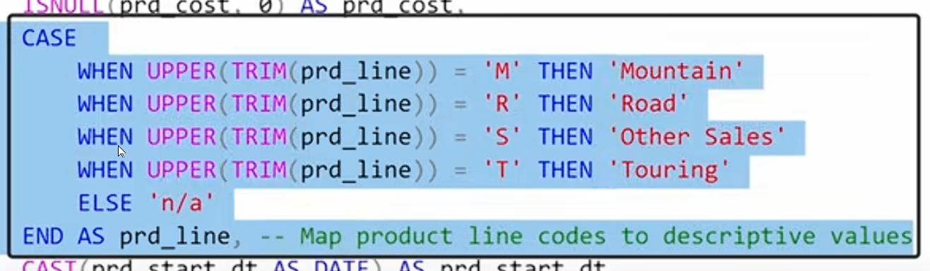data normalization

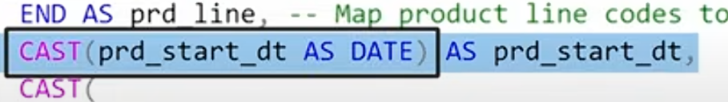data type casting. We convert one data tye to another

